Ashton T
tiltona@oregonstae.edu
Yousef A
alharyou@oregonstate.edu
Seth E
evansset@oregonstate.edu

11/29/23

Vending Machine with Display

1. Project Description: What your project does including anything extra you did/modified

Our mission is to implement the software and hardware of a standard vending machine system. We will start from the ground up, laying our foundation for the logic of the process.

Our machine in particular is a standard vending machine that allows the user to input nickels, dimes, and quarters. For our example, we’ll say it's a soda machine. The machine must be able to store more than one coin and can refund the user if they insert more than the cost to dispense. In our case, the machine requires $0.25, at least, to dispense a bottle. Between every state of the system, we must also always display the money inserted on a hexadecimal display. After the system either dispenses or refunds, the machine should reset.

A great way to tackle this problem is to start with a finite-state machine diagram [1a]. In this schematic, you get a great visual representation of the transitions between each possible state [1b]. It is from there that we can start to implement the logic.

The lowest abstraction levels involve logic. We need to consider every possible combination. We will achieve this by using a truth table.

In this binary finite-state machine truth table [3], we are using a two-bit operation to switch two states. We will use six switches on the FPGA, each capable of being high or low. Each switch represents an input: State A, State B, Nickel, Dime, Quarter, and Next State. We can then use these combinations to test our outputs: Bottle deposited and Return. The table will clearly show us these combinations that yield high. We can then map these highs using a Karnaugh map.

We will then use the Kmap to get an estimate of what our system's combinational logic will look like using a schematic with gates, adders, comparators, etc. Yet this is only half of the problem. Our system also relies on sequential logic, due to its reliance on memory storage of the previous state. This is where clocks, flip-flops, and registers come into play.

Now that the logic is laid out, we can move to the hardware implementation. We are using Intel Quartus and ModelSim for simulation, as well as an FPGA to test the logic.

2. Project Reflection: What went right and what went wrong overall?

The project went great. The parts that went the smoothest were the FSM diagram and the video presentation. The hardest part was wrapping our heads around the project. Setting up the logic, deciding to set up the binary truth table, and implementing the logic schematic proved to be difficult. Especially when considering how to involve the reset and return capabilities.

One downside that hindered our ability was that I am not a part of the lab this term therefore I did not have an FPGA, so I was very limited in how I could help for the hardware side of this project.

3. Block/Logic Diagram: an image showing all of the pieces of your design and how they
Interconnect
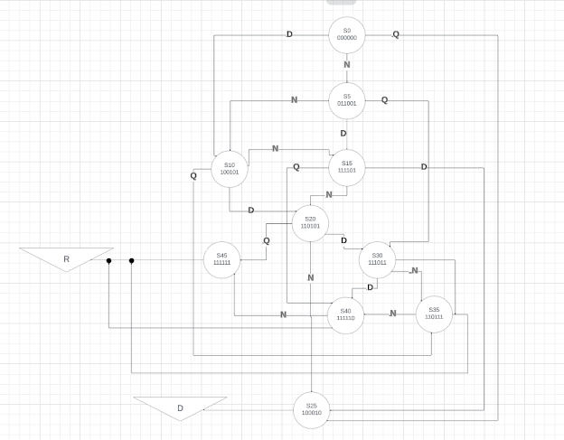
Figure 1a - Vending machine finite-state machine ()

A real-life example
Depicted above is a diagram showing each state possible. For example, we could use a real-life example where the user inserts a dime and a nickel for a value of $0.15. We’ll look at state 15 (S15) and its binary equivalent to make sense of it. We can achieve this state when our system equals 111101. This means that:
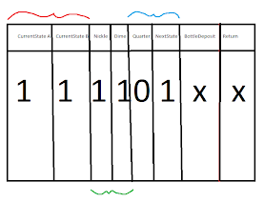
Figure 1b - finite-state of 111101

- We have two coins stored
- They are a nickel and a dime
- Not a quarter and we will need a next state to vend
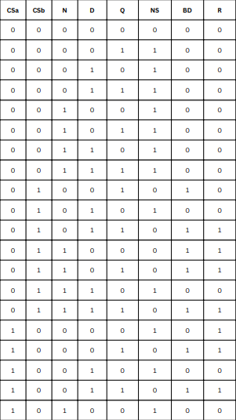
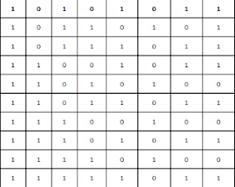
Figure 3 - Vending machine binary truth table

Below are the 6-input Kmaps, converted to Logic Diagrams for each output: BD = Bottle deposited & (R)eturn
Where,
A = Current State A
B = Current State B
C = Nickel
D = Dime
E = Quarter
F = Next State

Bottle Deposited

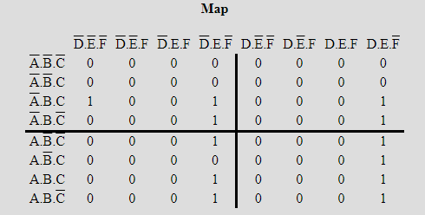
Figure 4a: A sum of products Kmap for bottle deposited

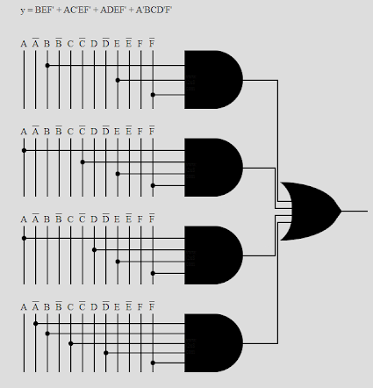
Figure 4b: A logic diagram for bottle deposited

Return Change

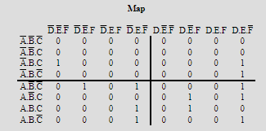
Figure 5a: A sum of products Kmap for return change
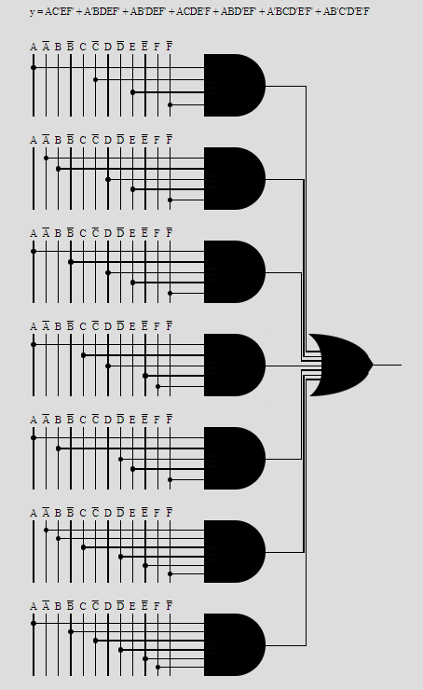
Figure 5a: A sum of products logic diagram for return change

4. Block Descriptions: These would be multiple sections that either describe what this block
is/does or in the case of a custom-created block includes the logic/contents of the block and why it works.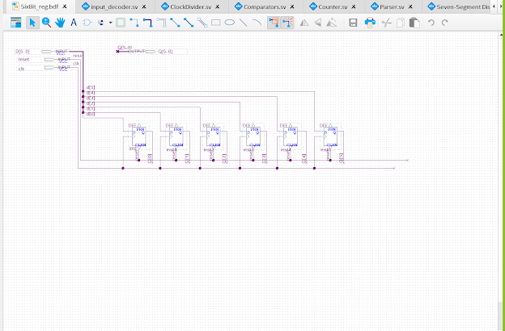
This is six bits register that can store 0 to 63 specific set numbers.

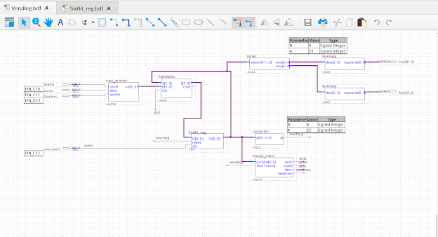
This is the whole schematic after connecting every module or block together. Basically, we have 3 inputs that go inside our input decoder and output a six bit output that goes to our six bit adder(specifically into the B’s in the adder). The six bit adder will output z that goes into our register(six bit register that takes a clock, reset and z as an input), the register will output Q that goes in the six bit adder(to the A’s), parser, comparator and the change_maker module. The comparator will see if the number is greater than 25 to send a signal to the register and the change maker that will output vend, nickel, dime or two dimes(if we reached 45 cents). At the end the signal that comes from the register into the parser will display on our seven segment lcd to show us how much money is inserted.

5. Simulation Results: Images, tables, etc.. and a description of them and why they prove
your project works correctly.
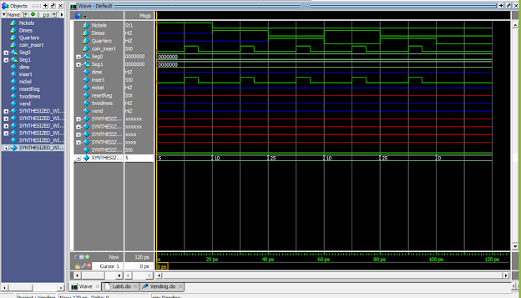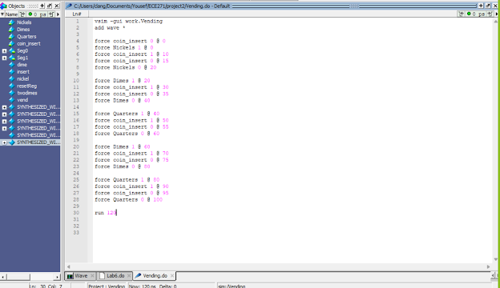
6. Video Link:
https://media.oregonstate.edu/media/t/1_0n8ljf6a

7. Appendix: Include all System Verilog and do files. Anything else that is important but not included above can be here as well.

